Homework 6

Due: 11:59 PM on Wednesday, April 21, 2021.

Please answer in your own words. Show your work.

1. (20 points) Consider the data bit stream: 10101 01000 01110 10001 00001 and use a two-dimensional bit parity code (with 5 rows and 5 columns as given in the textbook) with an even parity scheme.
   1. Write the matrix format for the parity code, assuming no errors for this bit stream.

Answer:

1 0 1 0 1 1

0 1 0 0 0 1

0 1 1 1 0 1

1 0 0 0 1 0

0 0 0 0 1 1

0 0 0 1 1 0

* 1. Now suppose that we receive the following data bit stream instead: 10101 01100 01110 10001 00001, which contains a one bit error. Show how you would use the parity code to detect the bit error.

Answer

Received bit stream is : 10101 01100 01110 10001 00001

Parity code for row: 00011

column : 11101

1 0 1 0 1 1

0 1 1 0 0 1

0 1 1 1 0 1

1 0 0 0 1 0

0 0 0 0 1 1

0 0 0 1 1 0

We will calculate again the odd and even number of one for each row and column and find where the value is not matching with party one.

So we identified that the second row and third column is not matching with parity , so when we draw box on that column we found the error is at second row third entry:

10101 01100 01110 10001 00001

1. (15 points) Consider a Slotted-ALOHA system with nodes that are all attempting to send packets after a collision. Assuming that each node will retransmit with probability at the beginning of the next slot, determine the probability (i.e., find the expression) that:
   1. no nodes retransmit on the next slot.

Answer:

“The probability that a given slot is a successful is that one of the nodes transmits and that the remaining N - 1 nodes do not transmit. The probability that a given node transmits is p; the probability that the remaining nodes do not transmit is (1 - p)N-1 . Therefore the probability a given node has a success is p(1 - p)N-1  .”[2]

Thus the probability that N nodes transmit is Np(1 - p)N-1 .

So For no node to retransmit/transmit would be given by 1- probability of N node successfully transmit.

1- [Np(1 - p)N-1]

* 1. exactly one node retransmits on the next slot.

Answer:

For Exactly one node transmission probability is:

p(1 - p)N-1.

* 1. exactly two nodes retransmit on the next slot.

Answer:

For Exactly two node transmission probability is p(1 - p)N-1 + p(1 - p)N-1 =

2p(1 - p)N-1.

1. (20 points) Consider the following CRC example in the lecture notes:

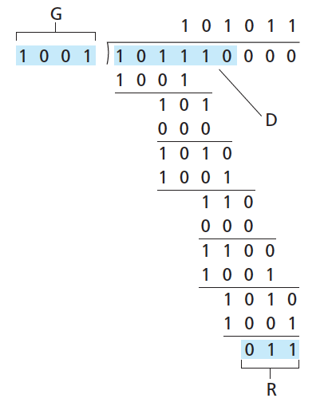

However, instead of the above value for , assume that is instead (a) 10010001,

Answer:

10000011

1001 10010001000

1001

0000

0000

0100

1001

1101

1001

1000

1001

001 R

(b) 10100011, and

Answer:

10110101

1001 10100011000

1001

1100

1001

1011

1001

1010

1001

1100

1001

101 R

(c) 01010101 with still remaining 1001 in each case, calculate the resulting value of for each case.

Answer:

0101111

1001 01010101000

0000

1010

1001

1110

1001

1111

1001

1100

1001

1010

1001

110 R

d. Suppose that the generator polynomial is used with the received message , which includes the CRC bits . Determine whether or not the received message has detectable errors or not. Be sure to show your work.

Answer:

First we will get the binary value of G(x) .

G(x) =

110101 (as in equation we can see we have power 5,4,2 and 0)

So the degree of G(x) is 5, so the message will become

To Find the tramitted data lets divided (XOR)message with G(x)

10100011

110101

110101

110111

110101

100101

110101

100001

110101

101001

110101

111000

110101

1101 R

Since the remainder has 1 in it. It shows the message has error.

1. (20 points): Suppose that two nodes sharing a single Ethernet transmit a packet at exactly the same time, causing a collision between these two packets.
2. Assuming that each of the nodes will attempt to retransmit again according to the CSMA/CD protocol with binary (exponential) backoff and that each node has only a single packet to transmit, what is the probability that they will collide again in their second attempt?

Answer:

Now for the second turn both nodes pick a random integer from set K={0,1}.

Suppose both choose the 0 and hence both will transmit, and collision occur.

Similarly, if both choose 1 collision will occur.

When one chooses 0 and other choose 1 the node which choose K= 0 wins

Hence the probability of win for node 1 is 1/4

Similarly, the probability of node 2 win is 1/4

**Out of 4 cases we can see the collision occurs probability is 2/4 = 1/2.**

1. What is the probability that they will collide a third time (with same assumptions)? In this calculation, you should only use that the two nodes have collided once (i.e., so for the third collision, you have to use your result from (a), rather than assuming with probability 1 that they have already collided two times).

Answer:

As the node has already experience two collision so the set K is of length 22. The nodes will choose random value from the set K.

K = {0,1,2,3}

So the probability of 2nd collision is : probability of collision on node1 + probability of collision on node2

= 1/8 + 1/8

=1/4

Probability of 3rd collision : probability of 2nd collision * probability of 3rd collision

: 1/2 *1/4

: 1/8

1. (25 points) Consider the following network:

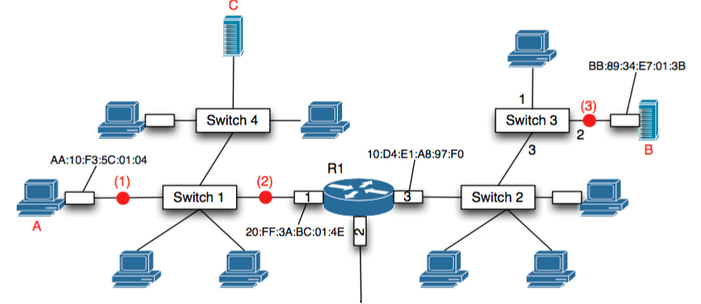

* 1. Suppose that node B sends a datagram to node A. What destination MAC address is on the frame that contains the ARP request?

Answer:

The destination MAC address is 10:D4:E1:A8:97:F0 to which the message will be broadcast .The ARP request is broadcasted to the entire network

* 1. At each point (1), (2), and (3) in the diagram above, what are the source and destination MAC addresses of this frame in part (a)?

Answer:

|  |  |  |
| --- | --- | --- |
| Point | Source Address | Destinations Address |
| 1 | 20:FF:3A:BC:01:4E | AA:10:F3:5C:01:04 |
| 2 | 20:FF:3A:BC:01:4E | AA:10:F3:5C:01:04 |
| 3 | BB:89:34:E7:01:3B | 10:D4:E1:A8:97:F0 |

* 1. After node B receives the ARP reply from (a) above, what information does Switch 3 now know (i.e., what is contained in Switch 3’s switching table)?

Answer:

It will know in ARP reply that the MAC address is unicasted to node A which will result in node A caching the IP-to-MAC address pair of switch 3 to ARP table.

References:

[1]: Computer Networking: A Top-Down Approach featuring Internet 7th edition, Kurose and Ross, Addison Wesley,

[2]: https://www.geeksforgeeks.org/back-off-algorithm-csmacd/